Woolcock Institute of Medical Research
The N-Back Working Memory Task
Technical Specifications for Research Tools

5/11/2018

The N-Back Working Memory Task
The participant is required to compare the spatial location of the current stimulus with that of one presented earlier.
In the easy, 1-Back WM task, the participant is required to match the position of the current stimulus with the position of the very first stimulus in the block. In the difficult, 2-Back WM task, the participant is required to match the position of the current stimulus with the position of the stimulus, which was presented two trials previously.

The n-Back assesses working memory, encompassing short term memory storage and information processing and reflects “central executive” processes. As mentioned above the participant is asked to compare the position of a letter displayed on the screen to the position of the letter presented 1, 2 or 3 trials previously. For example, for 2-back, the position of the 3rd letter is compared to the position of the 1st letter and the position of the 4th letter to the 2nd letter, and so on. If the position of the letters matched, the participant is to press ‘M’ on the keyboard for ‘Match’ as quickly as possible. If the position of the letters did not match, the participant pressed ‘N’ for ‘No Match’ as quickly as possible. The first of 50 trials is presented after 1.5 seconds with subsequent stimulus intervals of 4.5 seconds. Each n-Back task is 4 mins in duration and the percentage of total accuracy was calculated. The number of correct, incorrect and missed responses is also calculated.
Outcome measures:
Reaction time in milliseconds
Stimulus classification accuracy (calculation described at the end of this document)
Coefficient of variability (calculation described at the end of this document)
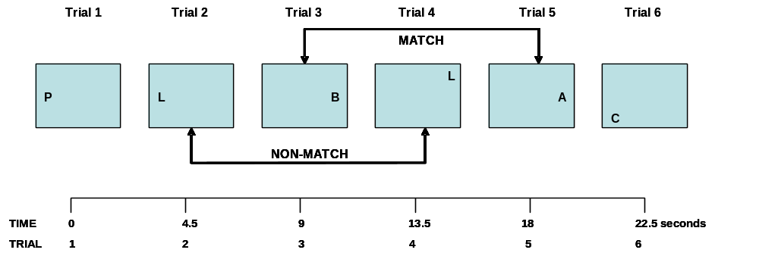
Illustration of the 2-Back task.

Every 4.5 seconds, one of 12 possible capital-letter stimuli appears in one of
12 possible locations on a computer monitor. The location of the stimulus is one of 12 locations on a imaginary circular grid (not visible). The possible stimulus locations are the intersection points of six equidistant imaginary radii of two imaginary circles, one at 1 cm and the other at 3.5 cm from the centre of the screen (the inner and outer circles of this array respectively subtend approximately 1.5 degrees and 4.5 degrees visual angle). Only a small fixation point is present in the center of the grid.
- the letters are white; the background is black
- The following 12 letters are used: B C F H L M P T W X Y Z
- Letter name and letter position occur with equal probability.
The display field of the task on the PC screen is quite small, to minimize eye movements. The identity of the letters is easily distinguished without having to foveate on it.
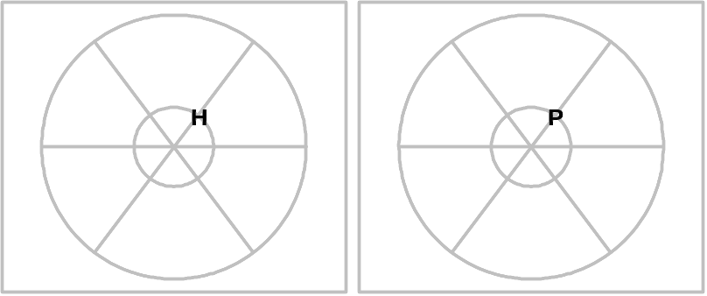

This capital-letter stimulus is presented for 250 milliseconds. At 1.5 seconds prior to stimulus onset, a warning cue in the centre of the screen appears for 200 milliseconds. The letter stimulus occurs 1.3 seconds after the cue disappears. The identity of the letter and its spatial position vary randomly from trial to trial. Matches occur on 50% of the trials. A test block, consisting of 50 trials, preceded by 2 redundant + 3 warm-up trials (discarded from analysis), has a duration of 4 minutes.
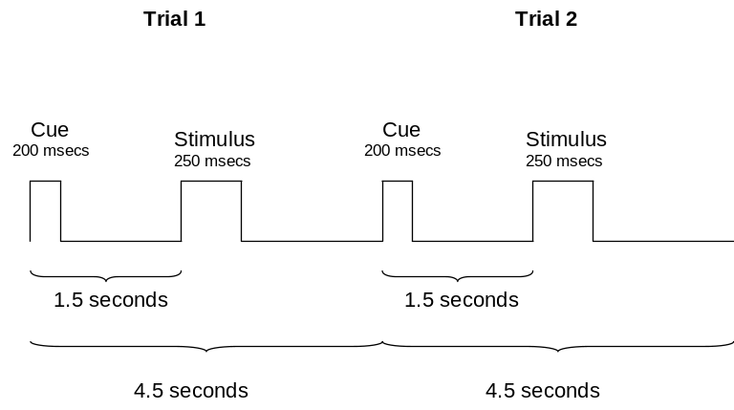

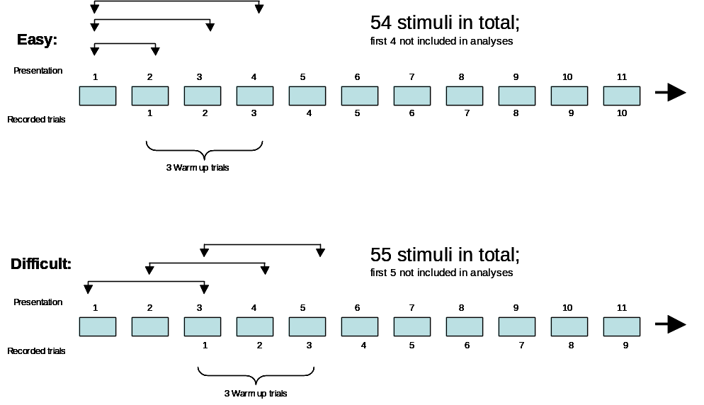

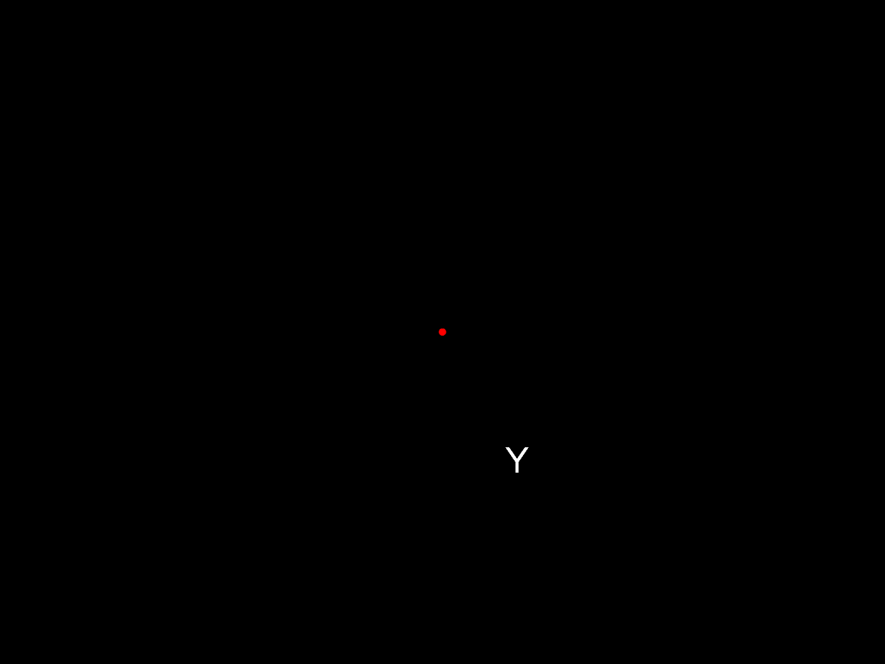

Settings Configuration File
The file 'N-Back Working Memory Task.txt' is a settings file you can open in Notepad or such-like to edit. The values in this file need to be set once, before running the program. The 'Pixels_Per_cm' and 'Letter_Size' values may need to be computed experimentally for the displays you are using. This file also includes the folder for saving results files. If all your test computers are on the network and all have identical file-paths to data folders then you can edit a single copy of this file and copy it to all computers before testing. The file must be copied to the same folder that the LabVIEW VIs are in.

The dimensions of the display field have to remain constant if different screen sizes are used.
The front-panel has been developed for the 1024x768 resolution, 12.1" display on a laptop. You need to adjust the position and sizing (and save) to suit the resolution of your displays. As long is this is done the rest is auto-scaling once the settings file values have been set correctly.

To compute the Pixels_per_cm, get a ruler and measure the width of your screen display area (in cm) then divide the horizontal resolution of your screen by this value. If the screen is 29cm wide and resolution is 1024x768, then Pixels_per_cm is 1024/29=35.3.

The black box which displays the stimuli is not automatically scaled in any way. The difference in size on different screens will be proportional to the size of the screens. So it needs to be adjusted to a size you are happy with. It should made big enough to comfortably fit the 3.5cm circle on my laptop screen.

Similarly, the same font size on different screens will differ in physical size by the the relative proportion of the screens. Just adjust the size to what you are happy with. It depends what font you choose, but valid fonts sizes are typically 8, 10, 12, 14, 18, 24 or 36 points. It seems you can set any point size and the font re-sizes accordingly.

Results Files
A raw data- and a summary data file (statistics) for each test block is generated, rather than a grand total analysis at the end of all tests. Both types of file are tab delimited text that can be opened with Excel. So to distinguish raw data files from summary files, these are named as "ID_Test#_raw.txt" and "ID_Test#_stats.txt". They are given the .xls extension even though they are not native Excel files so that the Open dialog in Excel can see them without having to select 'All Files'. They are written to the folder specified in the settings file.

As a point of note, with only 50 samples in total some of the statistics in the summary file are pretty meaningless if none or very few of a particular response type occurred

"Mean RT fastest 10% for correct Match + correct Non-Match" is the average of the fastest 10% of response times for CM and CN only.
Therefore, the "10%" stats would include a maximum of 5 observations. If all responses were correct then there would be 5. If 50% of responses were correct there would be only 2 or 3 and obviously it could in theory it could be less. I have forced these 10% stats to include a minimum of 1 observation. But this was not done so for other stats. In the unlikely case that no CM occurred obviously the stats for CM would be rubbish. Same for CN.

1. raw data file with : Reaction time in milliseconds for each trial.
This is recorded in real time (i.e. not delayed when the computer
processor is allocating resources to background processes) and accuracy for each trial:
CM (if correct Match)
CN (if correct Non-Match)
FM (if false Match; N-key was selected for a Match stimulus)
FN (if false Non-Match; M-key was selected for Non-Match stimulus)
O (if Omission - failure to respond in time allowable; for both Match
and Non-Match stimuli)
W (if wrong key entered, for both Match and Non-Match stimuli)
2. Summary data file (excluding the 2 redundant + 3 warm-up trials):
a) mean reaction time (RT) in msecs for correct Match + correct Non-Match
b) mean RT in msecs for correct Match
c) mean RT in msecs for correct Non-Match

d) Standard deviation (SD)for correct Match + correct Non-Match
e) SD for correct Match
f) SD for correct Non-Match
g) Median RT in msecs for correct Match + correct Non-Match
h) Median RT in msecs for correct Match
i) Median RT in msecs for correct Non-Match
j) minimum RT for correct Match + correct Non-Match
k) Maximum RT for correct Match + correct Non-Match
l) mean RT fastest 10% for correct Match + correct Non-Match
m) mean RT slowest 10% for correct Match + correct Non-Match
n) SD of fastest 10% RT for correct Match + correct Non-Match
o) SD of slowest 10% RT for correct Match + correct Non-Match
p) total number of correct Match + correct Non-Match
q) total number of correct Match
r) total number of correct Non-Match
s) total number of False Match + False Non-Match
t) total number of False Match
w) total number of False Non-Match
x) total number of Omissions
y) total number of Wrong keys

Three warm-up trials (plus 2 redundant trials) precede the 50 trials; these are discarded in the output files.

Random Generation of Position
Matches occur exactly 50% of the time, so that a random sequence of trials is computed in advance and then 50% of the trials are randomly chosen and replaced with matches. Pretrials are still based on 50% probability of a match.

Timing accuracy
It's important to realize that the timing accuracy (including response time measurement) is limited by how fast the software can run on the computer. If you are using good modern machines there should be no problem. It is not possible on a PC to get "real-time" accuracy with software. It is not possible to remove the effects of "when the computer processor is allocating resources to background processes" (specs email 8a). Real-time accuracy requires using external data acquisition hardware for timing. But my tests on my 850MHz PIII laptop indicate that delays in the stimulus timing sequence are all with 1ms or so and the measurement of response time is within 2 or 3 ms (possibly better). Other applications or background processes running on the computer should be minimized anyway.

At the start of the laboratory protocol, each participant is allocated his/her own laptop. He/she will complete each test on the same laptop throughout the entire protocol.

The program is initialized only once at the start of the protocol by entering the participant's ID number and test number (= '1'). Once you have clicked OK, the test will start immediately. Once a test has been completed, the next test can be started by clicking on the “Next” button (top left corner of screen), either by the experimenter or the participant. The test will start immediately.
Output files are saved in the directory specified in the settings configuration file (“N-back Working Memory Task” notepad). Each subsequent test is then saved automatically with the same ID number + subsequent test number (e.g. ID is 1001; test 1 is saved as 1001_1, test 2 is saved as 1001_2).
Access to the menu bar is disabled once the program has been initialized, so the participant cannot change any of the settings.

If the experimenter needs to abort the test while it is still running, open Task Manager (CTRL + ALT + Delete) and end the LabView program.

If the experimenter wants to reset the Nback task during the protocol, click on RESET once the test has finished; You’ll be asked to enter a password (password can be changed in settings configuration file); this allows you to roll back the test number and/or change the test level (easy/difficult). Once you’ve clicked OK, the test does NOT start automatically. Press the NEXT button to start the next test.

Stimulus classification accuracy (d’) - based on signal detection theory.
D-prime (d’), which is the standardized difference between the means of the ‘Signal present’ and ‘Signal absent’ distributions, is used here as a measure of detection sensitivity.
To calculate d’, you only need to know the participant’s hit and false alarm rates.

Hit = CM; Hit rate is number of CMs/25
False alarm = FN; False alarm rate is number of FNs/25

d’ = Z (H) – Z (FA)

where Z (H) and Z (FA) represent the transformation of the hit and false alarm rates to z-scores.
Larger absolute values of d’ mean that a person is more sensitive to the difference between ‘signal present’ and ‘signal absent’ distributions; d’ values near zero indicate chance performance.

In an Excel spreadsheet, you can calculate the Z-scores using the formula NORMSINV (prob), where prob is H or FA.
Note: if a Z-score is 1.000, change this to 0.999; if a Z-score is 0.000, change it to 0.001; d’ can otherwise not be calculated; d’ is the absolute value of Z (H) – Z (FA).

Coefficient of variability
Independently of overall slowing, reaction times become relatively more variable over test intervals, seen as an increase in the coefficient of variability. The coefficient of variability is the ratio of the standard deviation of reaction times over trials within a block of trials to the average of reaction times within each block, and is calculated as follows:
SD rt CMCN / mean rt CMCN of test x. (this is computed for each test and for each participant).

INSTRUCTIONS FOR PARTICIPANTS (to be displayed on page prior to each trial)

1-Back

This task compares the position of letters displayed on the screen.

Remember the position of the first letter.

Compare it to the position of all other letters.

If the position of the current letter matches the position of the first letter press M on the keyboard for Match as quickly as possible.

If the position of the current letter does not match press N for No Match as quickly as possible.
To begin, press the start button (a green dot will warn you that a letter is about to appear).

This task starts IMMEDIATELY after pressing start.

2-Back

This task compares the position of letters displayed on the screen.

Compare the position of the letter currently displayed on the screen to the position of the letter presented 2 trials previously.

For example: compare the position of the 3rd letter to the position of the 1st letter and the position of the 4th letter to the 2nd letter and so on.

If the position of the letters match press M on the keyboard for Match as quickly as possible.

If the position of the letters do not match press N for No Match as quickly as possible.
To begin, press the start button (a green dot will warn you that a letter is about to appear).

This task starts IMMEDIATELY after pressing start.

3-Back
This task compares the position of letters displayed on the screen.
Compare the position of the letter currently displayed on the screen to the position of the letter presented 3 trials previously
e.g. compare the position of the 4th letter to the position of the 1st letter and the position of the 5th letter to the 2nd letter and so on.
If the position of the letters match press M on the keyboard for Match as quickly as possible.
If the position of the letters do not match press N for No Match as quickly as possible.
To begin, press the start button (a green dot will warn you that a letter is about to appear).
This task starts IMMEDIATELY after pressing start.

References

Baddeley, A., R. Logie, S. Bressi, S. Della Sala, and H. Spinnler, Dementia and working memory. Q J Exp Psychol A, 1986. 38(4): 603-18.

Verstraeten, E., Neurocognitive effects of obstructive sleep apnea syndrome. Current Neurology and Neuroscience Reports, 2007. 7(2): 161-166.

